***Product Search Rest API***

***Assumptions:***

1. No Keywords exists when the application is initialized.
2. Two API’s are defined one for searching the exact keyword and one for searching the Keywords matching the prefix of the keyword entered.
3. GET exact keyword - <http://localhost:8080/estimate?searchKey=candle>
4. GET matching keywords - <http://localhost:8080/estimate/products?searchKey=candle>
5. Each Keyword will be added to the ProductList and the Rank will be incremented.

***Algorithm:***

GET exact keyword - <http://localhost:8080/estimate?searchKey=candle>

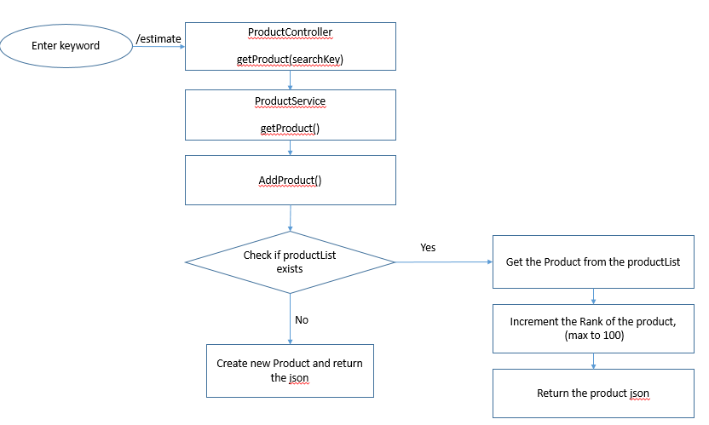

GET matching keywords - <http://localhost:8080/estimate/products?searchKey=candle>

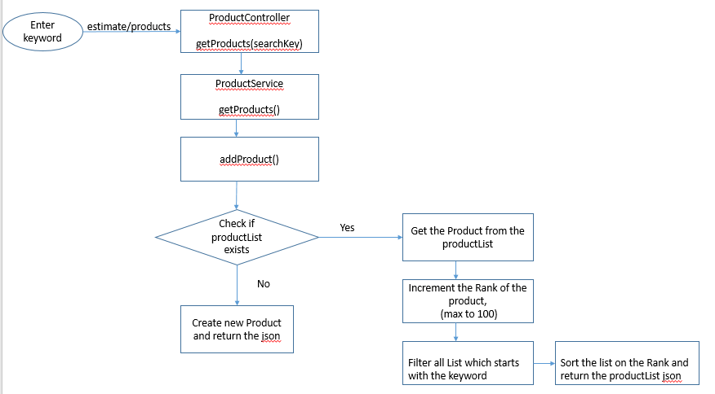

***Hint:***

The order of the 10 returned keywords is comparatively insignificant, Coz the order of the list is returned on the rank and not on the search keyword.

***Precise Outcome:***

As per my understanding of the problem statement and assumptions I made the output is precise.